Unit 6 Exam Review

Use this review to help you practice writing tangent line equations, using them to approximate solutions, and declaring error in an approximation. The questions from your AP FRQ packet, Differential Equations homework, and Euler’s method homework are more than adequate to prepare you for the test.

1) It is known that  and that the tangent line approximation for  is . Show that  .

2) Let  be the tangent line to the graph of  centered at and let  . Use the graph of  to find an interval where  must lie.

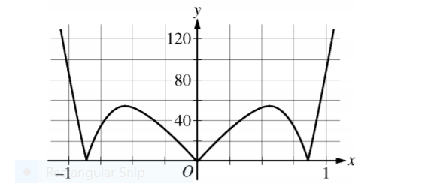

Graph of 

3) Let  be a twice-differentiable function defined on the interval  with . The graph of  , the derivative of  , is shown below. Let  be the function given by  .

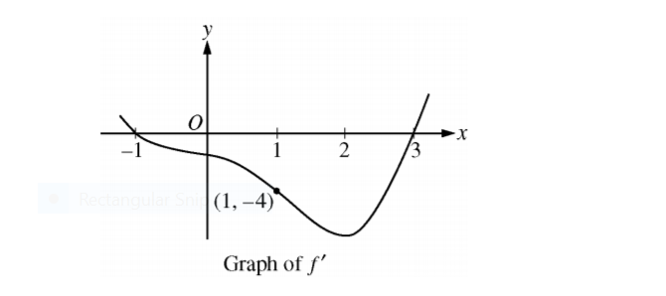

a) Write an equation for the line tangent to the graph of  at and use the equation of your tangent line to approximate  .

b) Use the error in the tangent line approximation to find an error bound for  .

4) Let  be a function having derivatives of all orders for  Selected values of  and its first two derivatives are indicated in the table below. The function  and these first two derivatives are increasing on the interval  .

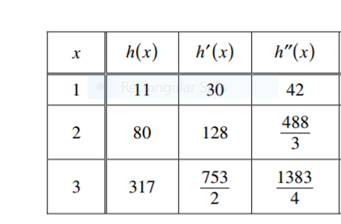

a) Write the equation for the line tangent to  at  and use it to approximate . Is this approximation greater than or less than  ? Explain your reasoning.

b) Use the tangent line error bound to show that  .