CALCULUS
WORKSHEET ON 3.1

Work the following on notebook paper. You may use your calculator to find  values.

1. For each of the labeled points, state whether the function whose graph is shown has an
absolute maximum, absolute minimum, local maximum, local minimum, or neither.
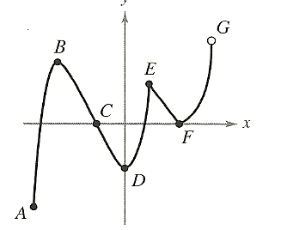
A ___________________ B ___________________

C ___________________ D ___________________

E ___________________ F ___________________

G___________________

__________________________________________________________________________________
2. Sketch the graph of a function f that is continuous on [0, 6] and has the given properties:
absolute maximum at x = 0, absolute minimum at x = 6, local minimum at x = 2, and
local maximum at x = 4.
__________________________________________________________________________________
Find the absolute maximums and absolute minimums of f on the given closed interval by using the
Candidates Test, and state where these values occur.
3. 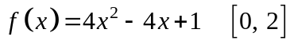 6. 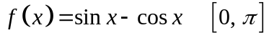

4. 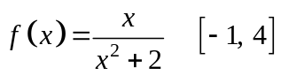 7. 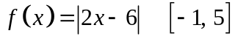

5. 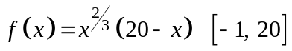
__________________________________________________________________________________
8. What is the smallest possible slope to 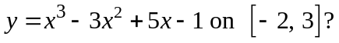
__________________________________________________________________________________
9. A particle moves along a straight line according to the position function 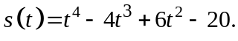
Find the maximum and minimum velocity on 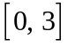. For what values of t do the maximum and
minimum occur?

Remember that velocity is the derivative of position.

CALCULUS
WORKSHEET ON ROLLE’S TH. & MEAN VALUE THEOREM

Work the following on notebook paper. Do not use your calculator on problems 1 – 3.
On problems 1 – 2, determine whether or not the conditions of Rolle’s Theorem are met. If the conditions are met, find the value of c that the theorem guarantees.
1. 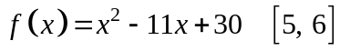
2. 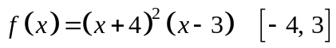
__________________________________________________________________________________
On problems 3 – 4, determine whether or not the conditions of the Mean Value Theorem are met.
If the conditions are met, find the value of c that the theorem guarantees.
3. 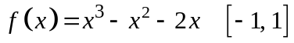
4. 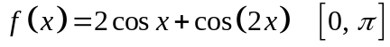 (Use your calculator.)
__________________________________________________________________________________
You may use your calculator on problems 5 – 6, but be sure you show supporting work.
5. A trucker handed in a ticket at a toll booth showing that in 2 hours, the truck had covered 159 miles
on a toll road on which the speed limit was 65 mph. The trucker was cited for speeding. Why?

6. A marathoner ran the 26.2 mile New York marathon in 2 hours, 12 minutes. Show that at least
twice, the marathoner was running at exactly 11 mph.
__________________________________________________________________________________
7. Given 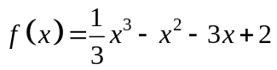. 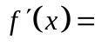____________________________
8. Use your calculator to graph and 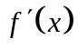 in the following window:
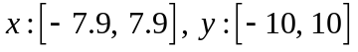. Sketch below.

9. The relative maximum and minimum values of occur at x = __________________

10. = 0 or is undefined at x = _______________

11. is increasing on what interval(s)? _______________

12. is positive on what interval(s)? _______________

13. is decreasing on what interval(s)? _______________

14. is negative on what interval(s)? _______________

TURN->>>

15. Given 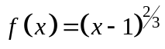. ____________________________

16. Use your calculator to graph and in the following window:
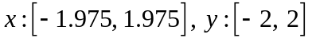. Sketch below.

17. The relative maximum and minimum values of occur at x = __________________

18.= 0 or is undefined at x = _______________

19. is increasing on what interval(s)? _______________

20. is positive on what interval(s)? _______________

21. is decreasing on what interval(s)? _______________

22. is negative on what interval(s)? _______________

_________________________________________________________________________________
Use your answers to problems 7 – 22 to complete the following statements:

23. The relative maximum and minimum values of f occurred when

_______________________________________________________________________________

24. The function f is increasing when ___________________________________________________

25. The function f is decreasing when __________________________________________________

CALCULUS
WORKSHEET ON DERIVATIVES

Work the following on notebook paper. Do not use your calculator.

1. Given 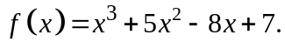 Use the Second Derivative Test to find whether f has a local
maximum or a local minimum at x = 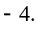 Justify your answer.

2. Given 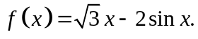 Use the Second Derivative Test to find whether f has a local
maximum or a local minimum at x = 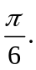 Justify your answer.
________________________________________________________________________________On problems 3 – 5, find the critical points of each function, and determine whether they are relative maximums or relative minimums by using the Second Derivative Test whenever possible.
3. 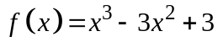
4. 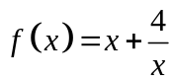
5. 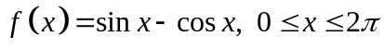 ________________________________________________________________________________
6. Consider the curve given by 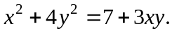
(a) Show that 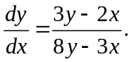
(b) Show that there is a point P with x-coordinate 3 at which the line tangent to the curve at P
is horizontal. Find the y-coordinate of P.
(c) Find the value of 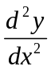 at the point P found in part (b). Does the curve have a local
maximum, a local minimum, or neither at point P? Justify your answer.
________________________________________________________________________________
On problems 7 – 8, the graph of the derivative, 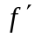, of a function f is shown.
(a) On what interval(s) is f increasing or decreasing? Justify your answer.
(b) At what value(s) of x does f have a local maximum or local minimum? Justify your
answer.

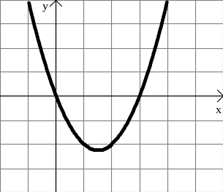
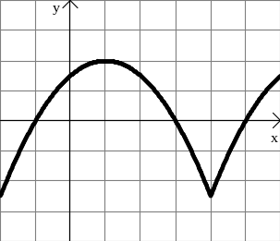
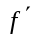7. 8.
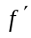

TURN->>>

9. The graph of the second derivative, 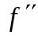, of a function f is shown. State the x-coordinates
of the inflection points of f. Justify your answer.

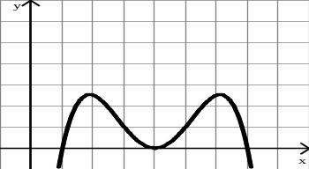
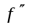

________________________________________________________________________________
10. For what values of a and b does the function 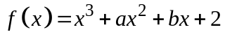 have a local
maximum when 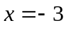 and a local minimum when 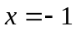?
________________________________________________________________________________
11. The graph of a function f is shown on the right.
Fill in the chart with +, , or 0.
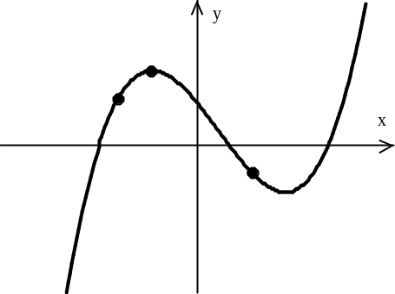
B

Point | f |  | A
A
B
C |  |  | C

________________________________________________________________________________
12. The function h is defined by 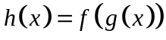, where f and g are the functions whose
graphs are shown below.
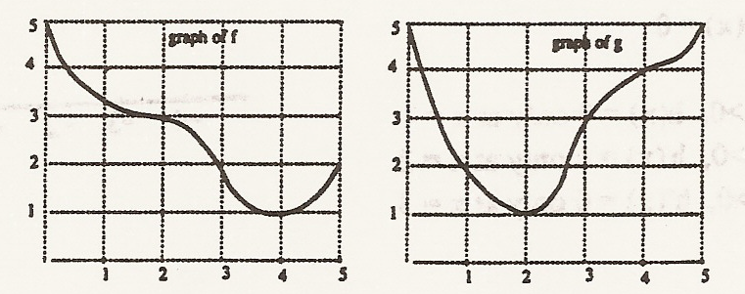

(a) Evaluate 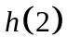.
(b) Estimate 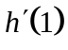.
(c) Is the graph of the composite function h increasing or decreasing at x = 3? Show your
reasoning.
(d) Find all values of x for which the graph of h has a horizontal tangent. Show your reasoning.

CALCULUS
WORKSHEET – A SUMMARY OF CURVE SKETCHING

Work the following on notebook paper.
On each problem, find:
1) the x- and y-intercepts
2) symmetry
3) asymptotes
4) intervals where f is increasing and decreasing
5) relative extrema
6) intervals where f is concave up and concave down
7) inflection points
Justify your answers and use the information found above to sketch the graph.

1. 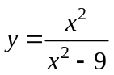

2. 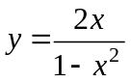

3. 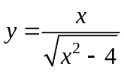

CALCULUS
WORKSHEET ON 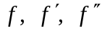
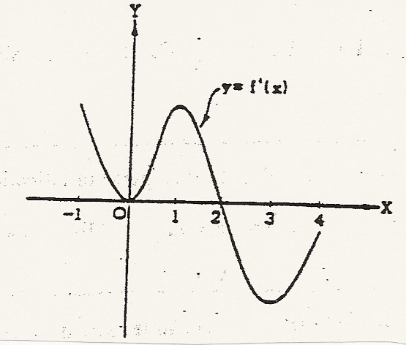
1.

Graph of
Let f be a function that has domain the closed interval [– 1, 4] and range the closed
interval [– 1, 2]. Let 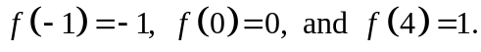 Also let f has the derivative
function that is continuous and that has the graph shown in the figure above.
(a) Find all values of x for which f assumes a relative maximum. Justify your answer.

(b) Find all values of x for which f assumes its absolute minimum. Justify your answer.

(c) Find the intervals on which f is concave downward.

(d) Give all values of x for which f has a point of inflection.

(e) Sketch the graph of f.

_______________________________________________________________________________
2. A function f is continuous on the closed interval [– 3, 3] such that 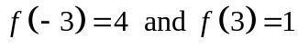.
The functions 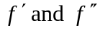 have the properties given in the table below.

x | 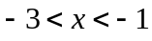 |  | 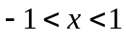 | x = 1 | 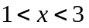
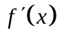 | Positive | Fails to exist | Negative | 0 | Negative
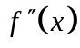 | Positive | Fails to exist | Positive | 0 | Negative

(a) What are the x-coordinates of all absolute maximum and absolute minimum points of f
on the interval [– 3, 3]? Justify your answer.

(b) What are the x-coordinates of all points of inflection of f on the interval [– 3, 3]?
Justify your answer.

(c) Sketch a graph that satisfies the given properties of f.

3. If 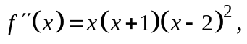 then the graph of f has inflection points when x =
(A) 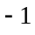 only (B) 2 only (C) and 0 only
(D) and 2 only (E) , 0, and 2 only

________________________________________________________________________________
4. An equation of the line tangent to 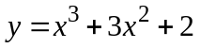 at its point of inflection is
(A) 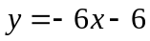 (B) 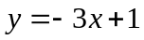 (C) 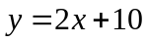
(D) 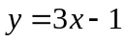 (E) 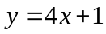

________________________________________________________________________________
5. If the graph of 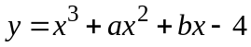 has a point of inflection at 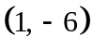, what is the value of b?
(A) – 3 (B) 0 (C) 1
(D) 3 (E) It cannot be determined from the information given.

_______________________________________________________________________________
6. For what value of x does the function 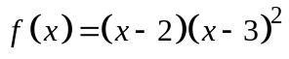 have a relative maximum?
(A) – 3 (B) 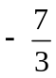 (C) 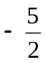 (D) 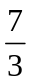 (E) 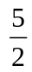

________________________________________________________________________________
7. Let f be the function defined by 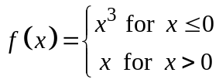. Which of the following statements
about f is true?
(A) f is an odd function. (B) f is discontinuous at x = 0.
(C) f has a relative maximum. (D) 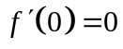 (E) 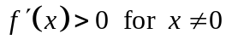.

________________________________________________________________________________
8. If 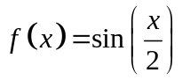, then there exists a number c in the interval 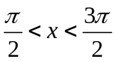 that satisfies the
conclusion of the Mean Value Theorem. Which of the following could be c?
(A) 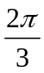 (B) 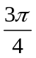 (C) 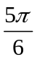 (D) (E) 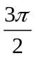

CALCULUS
WORKSHEET ON 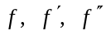

Work the following on notebook paper.
For problems 1 – 6, give the signs of the first and second derivatives for each of the following functions.
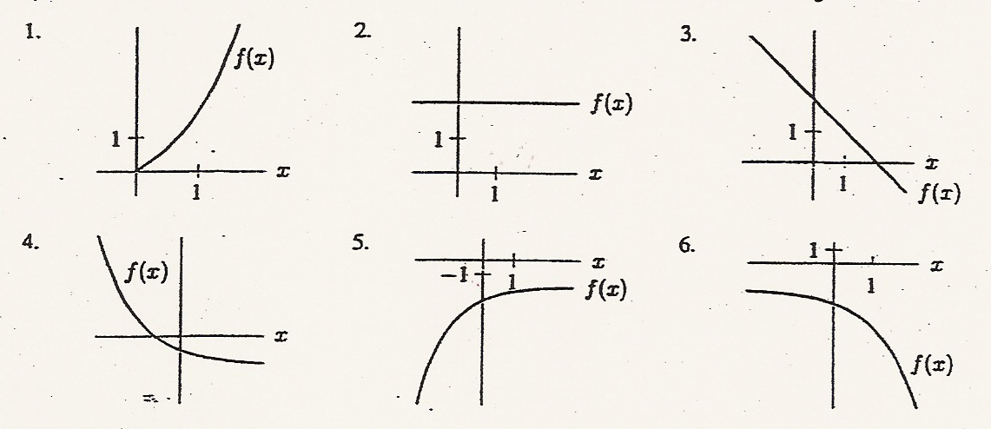

________________________________________________________________________________
7. (a) Water is flowing at a constant rate into a cylindrical container standing vertically.
Sketch a graph showing the depth of water against time.
(b) Water is flowing at a constant rate into a cone-shaped container standing in its vertex.
Sketch a graph showing the depth of the water against time.
______________________________________________________________________________________________
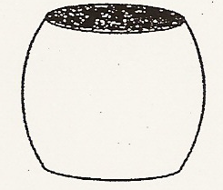
8. If water is flowing at a constant rate into the Grecian urn in the figure on
the right, sketch a graph of the depth of the water against time. Mark on
the graph the time at which the water reaches the widest point of the urn.

______________________________________________________________________________________________
9. Let f be a polynomial function with degree greater than 2. If 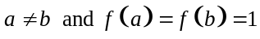, which of the
following must be true for a least one value of x between a and b?
I. 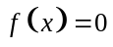
II. 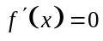
III. 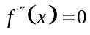
(A) None (B) I only (C) II only (D) I and II only (E) I, II, and III

________________________________________________________________________________________________
10. The absolute maximum value of 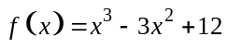 on the closed interval 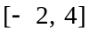 occurs at x =
(A) 4 (B) 2 (C) 1 (D) 0 (E) – 2

________________________________________________________________________________________________
11. At what value of x does the graph of 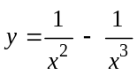 have a point of inflection?
(A) 0 (B) 1 (C) 2 (D) 3

TURN->>>

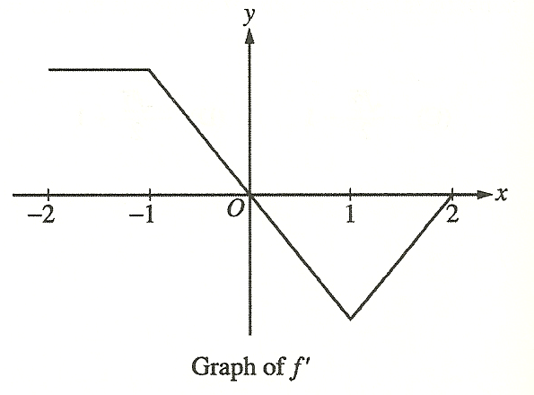

12. The graph of 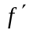, the derivative of the function f, is shown above. Which of the following statements is
true about f ?
(A) f is decreasing for 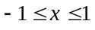. (B) f is increasing for 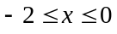.
(C) f is increasing for 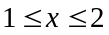. (D) f has a local minimum at x = 0.
(E) f is not differentiable at 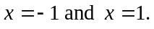
_______________________________________________________________________________________________
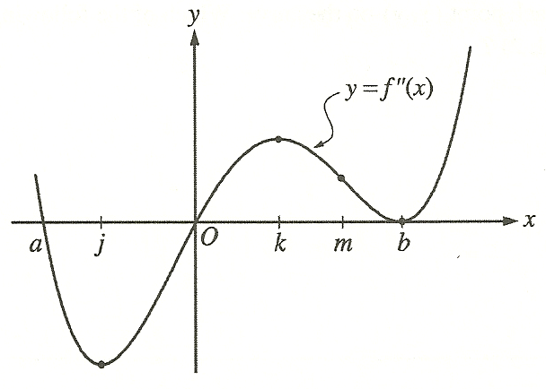
13.

The second derivative of the function f is given by 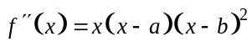. The graph of 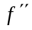 is
shown above. For what values of x does the graph of f have a point of inflection?
(A) 0 and a only (B) 0 and m only (C) b and j only (D) 0, a, and b (E) b, j, and k

________________________________________________________________________________________________
14. For all x in the closed interval [2, 5], the function f has a positive first derivative and a negative second
derivative. Which of the following could be a table of values for f ?
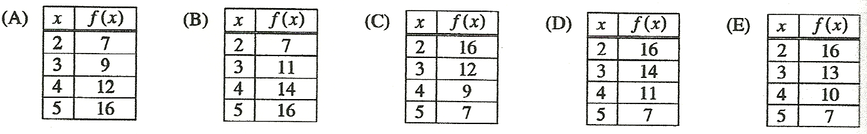

________________________________________________________________________________________________
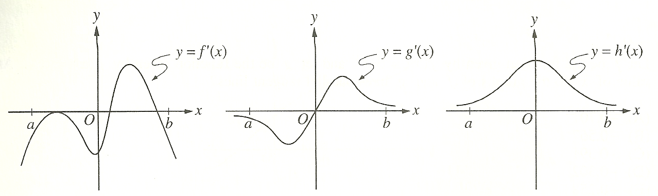

15. The graphs of the derivatives of the functions f, g, and h are shown above. Which of the functions
f, g, or h have a relative maximum on the open interval 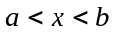?
(A) f only (B) g only (C) h only (D) f and g only (E) f, g, and h

