**2.5 Implicit Differentiation**

Examples of **explicitly** defined functions: Examples of **implicitly** defined functions:

 

 



______________________________________________________________________________

Ex. Given ,

(a) Differentiate with respect to *t*. Since you must apply the Chain Rule, each derivative will have

a  as part of the derivative.



(b) Differentiate with respect to *w*. Since you must apply the Chain Rule, each derivative will have

a  as part of the derivative.



(c) Differentiate with respect to *x*. Since you must apply the Chain Rule, each derivative will have

a  as part of the derivative.



Now use Algebra to rearrange and solve for .

Ex. Find the derivative, .

(a)  (b) 

If you have a Titanium TI-89, it has an implicit differentiation command built in. It’s under F3.

To check example (a), type: 

Since TI-83’s and 84’s cannot do this, implicit differentiation is always on the noncalculator portion of the AP Test.

________________________________________________________________________________

Ex. Find the second derivative, , given .

To check this example on your calculator, type: 

The 2 at the end of the command tells the calculator to find the second derivative.

|  |
| --- |
| **Homework**: P. 146: 1 – 33 eoo, 45 – 49 odd, 65, 77, 78 |

**2.5 Implicit Differentiation, Day 2**

Ex. Consider the curve given by  

(a) Find .

(b) Write the equation of the tangent line to the curve at the point .

(c) Find the coordinates of the point(s) on the curve where the line tangent to the curve is vertical.

|  |
| --- |
| **Homework**: Worksheet |

**More on Definition of the Derivative**

Ex. Evaluate the following by recognizing that the given limit represents a derivative.

|  |
| --- |
| **Definition of the derivative**: |

(a) 

(b)

(c) 

**Related Rates**

In the last section we learned to differentiate implicitly defined functions by using the Chain Rule. In this section we will use the Chain Rule to find the rates of change of two or more variables with respect to time, giving us expressions such as .

Ex. Suppose . Find  when *x* = 4, given that  when *x* = 4.

________________________________________________________________________________

Ex. A pebble is dropped into a calm pond, causing ripples in the shape of concentric circles. The

radius of the outer ripple is increasing at a constant rate of 1 ft/sec. When the radius is 4 ft,

find the rate at which the area of the disturbed water is changing.

________________________________________________________________________________

Ex. Water runs out of a conical tank at the constant rate of 2 cubic feet per minute. The radius at

the top of the tank is 5 feet, and the height of the tank is 10 feet. How fast is the water level

sinking when the water is 4 feet deep?

|  |
| --- |
| **Sphere:**  **Cone:**  **Cylinder:** |

|  |
| --- |
| **Homework: P. 154: 3, 9, 13, 17, 18, 20 - 22** |

**Related Rates, Day 2**

Ex. A fish is reeled in at a rate of 2 ft/sec from a bridge 16 ft above the water. At what rate is the

angle between the line and the water changing when there are 20 ft of line out?

________________________________________________________________________________

Ex. A man 6 ft tall walks at a rate of 5 ft/sec toward a lightpole 16 ft tall.

(a) At what rate is the tip of his shadow moving when he is 10 ft from the base of the light?

(b) At what rate is the length of his shadow moving when he is 10 ft from the base of the light?

________________________________________________________________________________

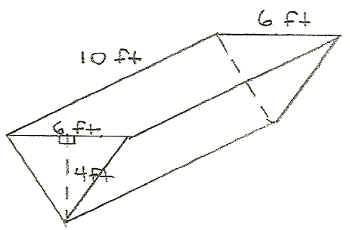Ex. A trough is 10 ft long and 6 ft across the top. Its ends are

isosceles triangles with an altitude of 4 ft. If water is being

pumped into the trough at 9 /sec, how fast is the water

level rising when the water is 2 ft deep?

|  |
| --- |
| **Homework: Worksheet** |