AP Calculus BC Unit 2.1 Test Review

1) Sketch the graph of a function *f,* where *f* has a limit at *x* = 3 but it is not continuous at *x* = 3.

2) Find the value of that will make the function continuous everywhere

3) Given :

(a) Sketch the function and the tangent line to the graph at the point where *x* = 1.

(b) Based on your sketch, do you expect  to be positive or negative?

(c) Compute  by using any of the three definitions of the derivative forms.

(d) Write the equation of the tangent line to the graph of  at *x* = 1. Leave your equation in point-slope form, 

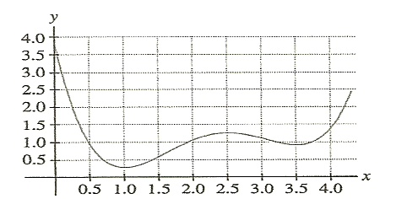4) Use the graph of the function on the right to determine

the intervals along the *x*-axis on which the derivative

is positive.

5) The function is continuous on the closed interval [0 , 2] and has values that are given in the table below. Find a value for so the equation has at least two solutions on the interval [0 , 2].

|  |  |  |  |
| --- | --- | --- | --- |
| X | 0 | 1 | 2 |
| f(x) | 1 | k | 2 |

6) For each of the graphs shown below, list the *x*-values for which the function appears to be:

(i) not continuous (ii) not differentiable

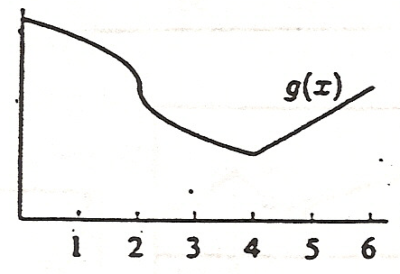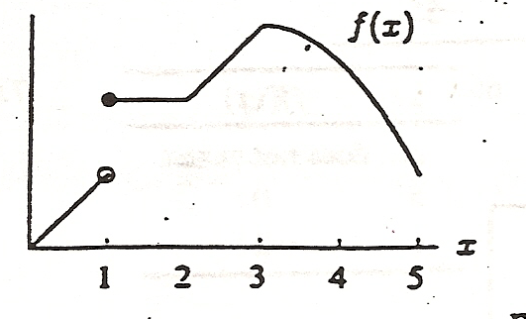

7) Let be the function defined below, where *c* and *d* are constants. If is differentiable at *x*=2, what is the value of *c* + *d* ?



8) The temperature of the water in a pond is modeled by a differentiable function *T* for  where *t* is measure in days and  is measured in degrees Celsius. Values of  at selected values of *t* are shown in the table below.

|  |  |  |  |  |  |  |
| --- | --- | --- | --- | --- | --- | --- |
| *t* (days) | 0 | 3 | 6 | 9 | 12 | 15 |
| (°C) | 20 | 31 | 28 | 24 | 22 | 20 |

(a) Use data from the table to find . Using appropriate units, explain the meaning of your answer.

(b) Use data from the table to find an approximation for . Show the computations that lead to your answer.

(c) Based on values in the table, what is the smallest number of instances at which the temperature of the pond could equal 23°C on the open interval 0 < *t* < 15? Justify your answer.

(d) A student proposes the function *P*, given by , as a model for the temperature of the water in the pond at time *t*, where *t* is measured in days and  is measured in degrees Celsius. Find. Using appropriate units, explain the meaning of your answer.

9) =

10) =

11) Find the value(s) of  where the graph of  is not differentiable. Explain why the graph is not differentiable there.

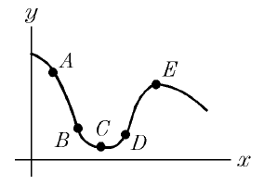12) At which labeled points is the slope of the graph:

a) positive?

b) zero?

c) Are the slopes increasing or decreasing from A to C? Why?