CALCULUS BC

WORKSHEET 1 ON IMPLICIT DIFFERENTIATION

Work the following on notebook paper. Show all work, and circle your answers.

On problems 1 – 4, find .

1.  3. 

2.  4. 

_________________________________________________________________________________________

5. (1998 Mult. Ch.) If 

(A)  (B)  (C)  (D)  (E) 

_________________________________________________________________________________________

6. (2003 Mult. Ch.) What is the slope of the line tangent to the curve  at the point (3, 2)?

(A) 0 (B)  (C)  (D)  (E) 

_________________________________________________________________________________________

7. (2008 BC 6 – Form B)

Consider the closed curve in the *xy*-plane given by 

(a) Show that 

(b) Write an equation for the line tangent to the curve at the point 

(c) Find the coordinates of two points on the curve where the line tangent to the curve is vertical.

(d) Is it possible for this curve to have a horizontal tangent at points where it intersects the *x*-axis?

Explain your reasoning.

__________________________________________________________________________________

8. (2004 BC 4)

Consider the curve given by 

(a) Show that 

(b) Show that there is a point *P* with *x*-coordinate 3 at which the line tangent to the curve at *P* is

horizontal. Find the *y*-coordinate of *P*.

(c) Find the value of  at the point found in part (b).

Answers to Worksheet on Implicit Differentiation

1. 

2. 

3. 

4. 

5. 

6. 

7. 2008 BC 6 – Form B

(a) 

(b) At 

Tangent line: 

(c) Vertical tangents at 

(d) No, the curve cannot have a horizontal tangent where it crosses the *x*-axis.

8. 2004 BC 4

(a) 

(b) *y* = 2

(c) 

**CALCULUS BC**

**WORKSHEET ON DEFINITION OF THE DERIVATIVE AND IMPLICIT DIFFERENTIATION**

Work these on **notebook paper**. Show all work, and circle your answers.

On 1 – 4, evaluate. Show the steps that lead to your answer.

1.  3. 

2.  4. 

________________________________________________________________________________________

5. If *f* is a differentiable function, then  is given by which of the following?

I.  II.  III. 

(A) I only (B) II only (C) I and II only (D) I and III only (E) I, II, and III

_________________________________________________________________________________________

6. 

7. 

8. 

CALCULUS

WORKSHEET 1 ON RELATED RATES

Work the following on notebook paper.

1. A ladder 15 feet tall leans against a vertical wall of a house. If the bottom of the ladder is pulled away

horizontally from the house at 4 ft/sec, how fast is the top of the ladder sliding down the wall when the

bottom of the ladder is 9 feet from the wall?

2. A particle moves along the curve  in such a way that  Find  when *x* = 3.

3. Two automobiles start from a point A at the same time. One travels west at 72 miles per hour; the other

travels north at 54 miles per hour. How fast is the distance between them increasing 3 hours after they

start?

4. An observer stands 25 feet from the base of a flagpole and watches a flag being

lowered at a rate of 5 ft/sec. Determine the rate at which the angle of elevation from

the observer to the flag is changing at the instant that the flag is 25 feet above eye-level.

25 ft.

5. A man 6 ft tall walks at a rate of 5 feet per second away from a light that is 15 ft above the ground.

When he is 10 feet from the base of the light,

(a) at what rate is the tip of his shadow moving?

(b) at what rate is the length of his shadow changing?

6. The length L of a rectangle is decreasing at the rate of 2 cm/sec while the width W is increasing at the

rate of 2 cm/sec. When L = 12 and W = 2, find the rate of change of:

a) the area of the rectangle

b) the perimeter of the rectangle

c) the length of a diagonal of the rectangle.

7. At a sand and gravel plant, sand is falling off a conveyor and onto a conical pile at a rate of 10 cubic ft per

minute. The diameter of the base of the cone is approximately three times the altitude. At what rate is the

height of the pile changing when the pile is 15 ft high? (The volume of a cone is given by .)

8. A conical tank (with vertex down) is 10 feet across the top and 12 feet deep. If water is flowing into the

tank at a rate of 10 cubic feet per minute, find the rate of change of the depth of the water when the water

is 8 ft deep.

Answers to Worksheet 1 on Related Rates

1. 

2. 

3. 

4. 

5. (a)  (b) 

6. (a)  (b)  (c) 

7. 

8. 

CALCULUS BC

WORKSHEET 2 ON RELATED RATES

Work these on **notebook paper**, showing all steps.

1. A paper cup, which is in the shape of a right circular cone, is 16 cm deep and has a radius of 4 cm. Water is

draining out of the cup at a constant rate of . When the radius has a length of 3 cm, what is the rate of

change of the radius? 

_____________________________________________________________________________________________

2. A snowball is in the shape of a sphere. Its volume is increasing at a constant rate of 10  How fast is the

radius increasing when the volume of the cone is? 

_____________________________________________________________________________________________

3. (1985) The balloon shown is in the shape of a cylinder with hemispherical ends of the

same radius as that of the cylinder. The balloon is being inflated at the rate of

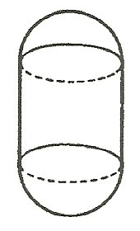  At the instant that the radius of the cylinder is 3 cm, the volume of the

balloon is  and the radius of the cylinder is increasing at the rate of 2



(a) At this instant, what is the height of the cylinder?

(b) At this instant, how fast is the height of the cylinder increasing?

_____________________________________________________________________________________________

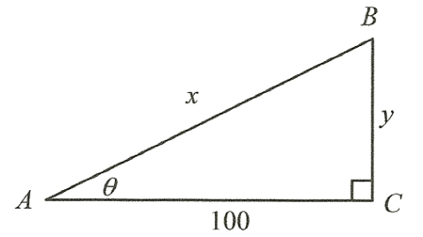4. (1988) The figure shown represents an observer at point A watching balloon B

as it rises from point C. The balloon is rising at a constant rate of 3 m/sec, and

the observer is 100 m from point C.

(a) Find the rate of change in *x* at the instant when *y* = 50.

(b) Find the rate of change in the area of right triangle BCA at the instant

when *y* = 50.

(c) Find the rate of change of  at the instant when *y* = 50.

_____________________________________________________________________________________________

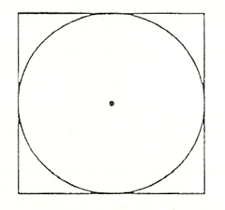5. (1994) A circle is inscribed in a square, as shown in the figure. The circumference

of the circle is increasing at a constant rate of 6 in/sec. As the circle expands, the

square expands to maintain the condition of tangency.

(a) Find the rate at which the perimeter of the square is increasing.

(b) At the instant when the area of the circle is find the rate

of increase in the area enclosed between the circle and the square.

**TURN->**

**Multiple Choice**. All work should be shown.

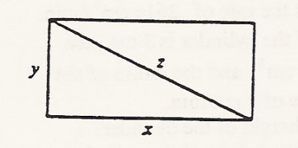6.

The sides of the rectangle above increase in such a way that .

At the instant when *x* = 4 and *y* = 3, what is the value of ?

(A)  (B) 1 (C) 2 (D)  (E) 5

_____________________________________________________________________________________________

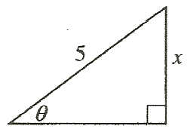7. (1997) If  increases at a constant rate of 3 rad/min, at what rate is *x* increasing

in units/min when *x* = 3 units?

(A) 3 (B)  (C) 4 (D) 9 (E) 12

_____________________________________________________________________________________________

8. (1998) If the base *b* of a triangle is increasing at a rate of 3 inches per minute while its height *h* is decreasing at

a rate of 3 inches per minute, which of the following must be true about the area *A* of the triangle?

(A) *A* is always increasing. (B) *A* is always decreasing.

(C) *A* is decreasing only when  (D) *A* is decreasing when 

(E) *A* remains constant.

_______________________________________________________________________________________

**Answers**

1. 

2. 

3. (a) 12 cm (b) 5

4. (a)  (b)  (c) 

5. (a)  (b) 

6. B

7. E

8. D