Graphing Parametric Equations and Eliminating the Parameter
Ex. Make a table of values and sketch the curve, indicating the direction of your graph. Then
eliminate the parameter.
(a)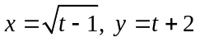
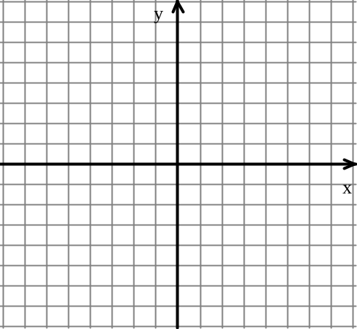

_________________________________________________________________________________________
(b) 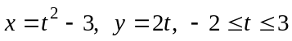

________________________________________________________________________________________
(c) 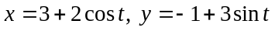

Homework: Worksheet

Parametric Equations and Calculus
If a smooth curve C is given by the equations 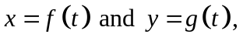
then the slope of C at the point 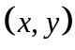 is given by 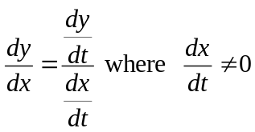,
and the second derivative is given by 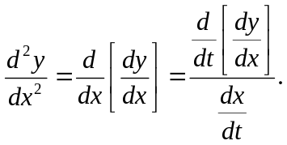
Ex. 1 (Noncalculator)
Given the parametric equations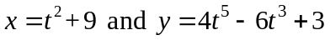, find 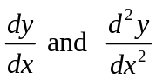 in terms of t.

__________________________________________________________________________________
Ex. 2 (Noncalculator)
Given the parametric equations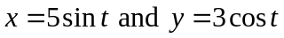, write an equation of the tangent line to the curve at the point where 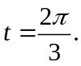

__________________________________________________________________________________
Ex 3 (Noncalculator)
Find all points of horizontal and vertical tangency given the parametric equations
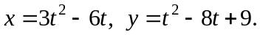

Earlier in the year we learned to find the arc length of a curve C given by 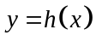 over the
interval 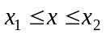 by 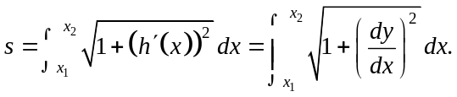
If C is represented by the parametric equations 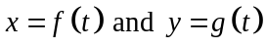 over the interval 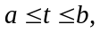
then
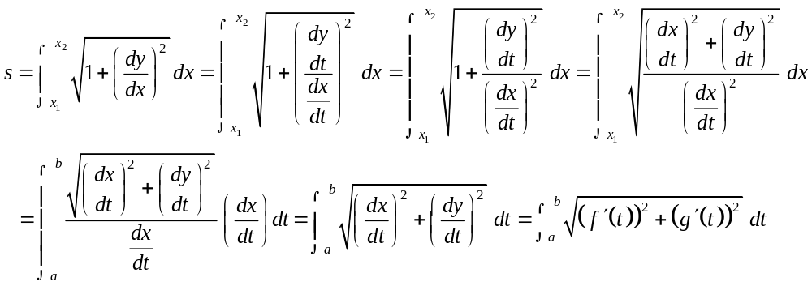

Length of arc for parametric graphs is 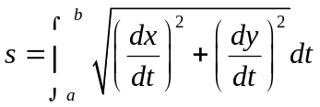.
Note that the formula works when the curve does not intersect itself on the interval and the curve must be smooth.

Ex. 4 (Noncalculator)
Set up an integral expression for the arc length of the curve given by the parametric
equations 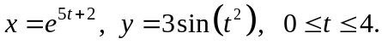 Do not evaluate.

Homework: Worksheet and AP Review 2-4

Parametric Equations, Vectors, and Calculus – Terms and Formulas to Know
If a smooth curve C is given by the equations then the slope of C
at the point 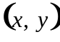 is given by, and the second derivative is given
by
_________________________________________________________________________________
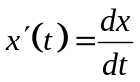 , introduced above, is the rate at which the x-coordinate is changing with respect to t or the velocity of a particle in the horizontal direction.

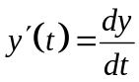 , also introduced above, is the rate at which the y-coordinate is changing with respect to t or the velocity of a particle in the vertical direction.
__________________________________________________________________________________
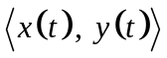 is the position vector at any time t.

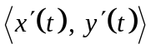 is the velocity vector at any time t.

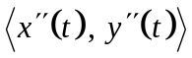 is the acceleration vector at any time t.
__________________________________________________________________________________
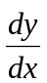 is the rate of change of y with respect to x or the slope of the tangent line to the curve or
the slope of the path of the particle.

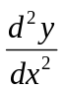 is the rate of change of the slope of the curve with respect to x.
__________________________________________________________________________________
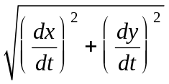is the speed of the particle or the magnitude (length) of the velocity vector.

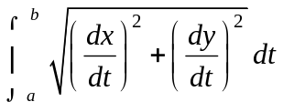 is the length of the arc for 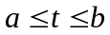 or the distance traveled by
the particle for 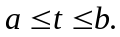

Vectors - Motion Along a Curve, Day 1
(All of the examples are noncalculator.)
Ex. 1 A particle moves in the xy-plane so that at any time t, the position of the particle is given by
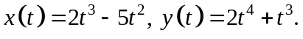
(a) Find the velocity vector when t = 1.

(b) Find the acceleration vector when t = 1.

__________________________________________________________________________________
How do you find the magnitude or length of a vector?

Position vector

Magnitude of the position vector =

__________________________________________________________________________________
Velocity vector

Magnitude of the velocity vector =

The magnitude of the velocity vector is called the speed of the object moving along the curve.
__________________________________________________________________________________
Acceleration vector

Magnitude of the acceleration vector =

__________________________________________________________________________________
Ex.2 A particle moves in the xy-plane so that at any time t, 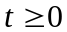, the position of the particle is given
by 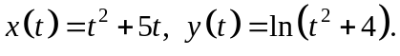 Find the magnitude of the velocity vector when t = 3.

Ex. 3 A particle moves in the xy-plane so that
The path of the particle intersects the x-axis twice. Write an expression that represents the
distance traveled by the particle between the two x-intercepts. Do not evaluate.

__________________________________________________________________________________
We learned earlier in the year that a particle moving along a line is at rest when its velocity is zero.
If a particle is moving along a curve, the particle is at rest when its velocity vector = 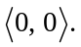

Ex. 4 A particle moves in the xy-plane so that at any time t, the position of the particle is given
by For what value(s) of t is the
particle at rest?

__________________________________________________________________________________
Ex. 5 A particle moves in the xy-plane in such a way that its velocity vector is 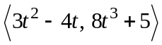.
At t = 0, the position of the particle is 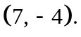 Find the position of the particle at t = 1.

Homework: Worksheet and AP Review 1

Vectors, Motion Along a Curve, Day 2
Use your calculator on the following examples.
Ex. A particle moving along a curve in the xy-plane has position at time t with 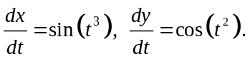 At time t = 2, the object is at the position ( 7, 4).
(a) Write the equation of the tangent line to the curve at the point where t = 2.

(a) Find the speed of the particle at t = 2.

(c) For what value of t, 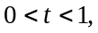 does the tangent line to the curve have a slope of 4? Find the acceleration
vector at this time.

(d) Find the position of the particle at time t = 1.

Homework: Worksheet and Polar Discovery Worksheet

Polar Coordinates and Polar Graphs
Rectangular coordinates are in the form 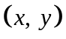.
Polar coordinates are in the form 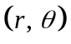.
________________________________________________________________________________
Ex. 1 Graph the following polar coordinates:
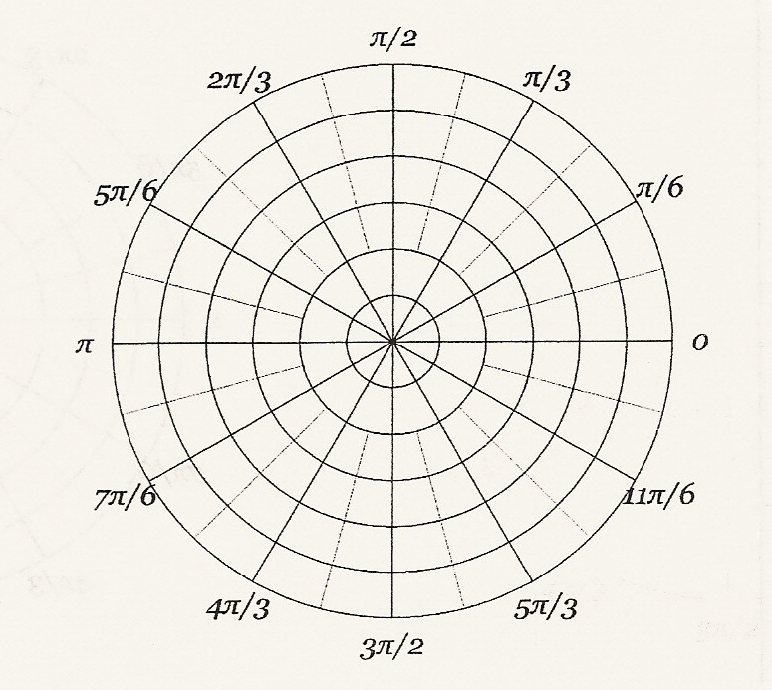
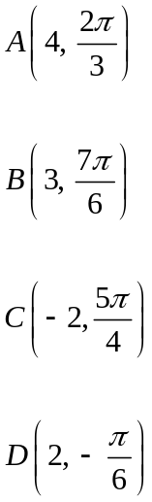

__________________________________________________________________________________________
In Precalculus you learned that:

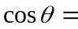 so x =

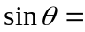 so y =

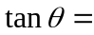

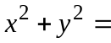 so r =

___________________________________________________________________________________________
Ex. Convert 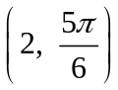 to rectangular coordinates.

__________________________________________________________________________________________
Ex. Convert 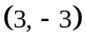 to polar coordinates.

Ex. Convert the following equations to polar form.
(a) y = 4 (b) 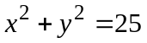

__________________________________________________________________________________________
Ex. Convert the following equations to rectangular form, and sketch the graph.
(a) 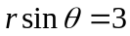 (b) 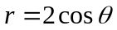 (c) 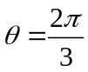

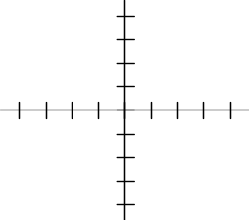

__________________________________________________________________________________________
To find the slope of a tangent line to a polar graph 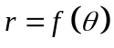, we can use the facts that 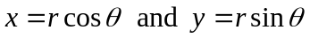, together with the product rule:
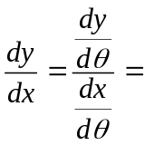

__________________________________________________________________________________________Ex. Find 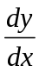 and the slope of the graph of the polar curve at the given value of .
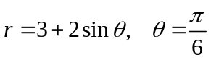

Homework: Worksheet and AP Review 6

Notes on Polar, Day 2 - Area Bounded by a Polar Curve
To find the area bounded by a polar curve, we need to start with the formula for the area of a sector of a circle.

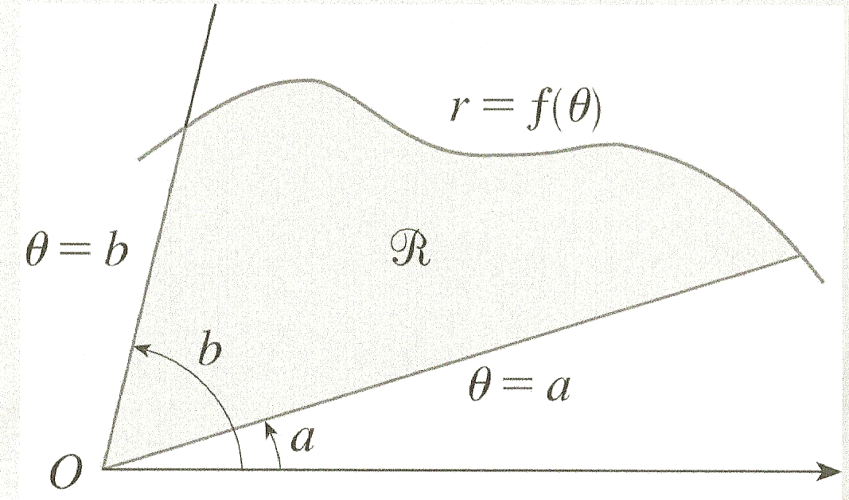
Area of a Sector = 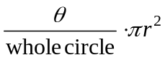

If is measured in radians, then

Area of a Sector = 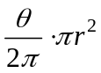 which simplifies to

Area of a Sector = 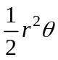

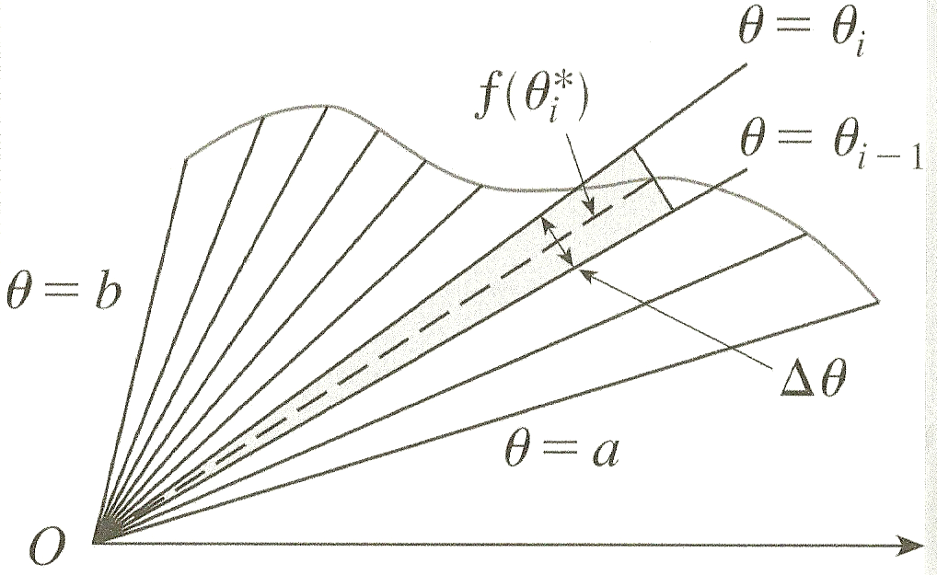
If we take a function 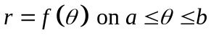
and partition it into equal subintervals, then the
radius of the ith subinterval = 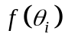and the
central angle of the ith sector = 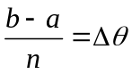.
Then the area of the region can be approximated by:
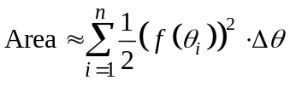.

To get the exact area, we can take the limit as the number of subintervals approaches infinity, so

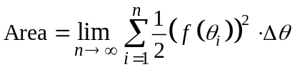

Then the Fundamental Theorem of Calculus allows us to evaluate this area by using a definite integral, so that

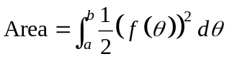 or 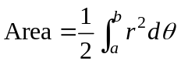

The area bounded by the polar curve 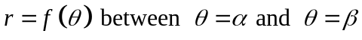 is given by the formula:
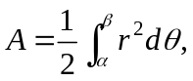

Ex. Sketch the graph of 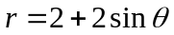and find the area bounded by the graph.
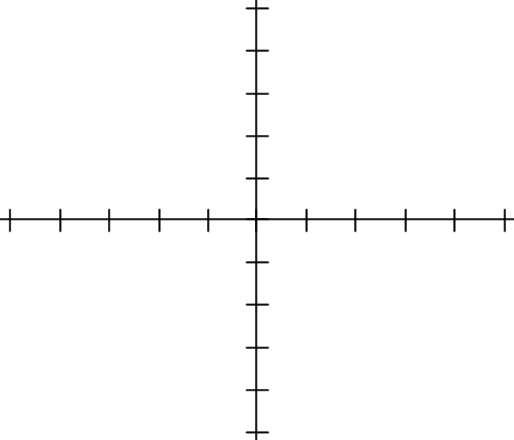

__________________________________________________________________________________________
Ex. Sketch, and set up an integral expression to find the area of one petal of 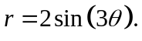
Do not evaluate.

__________________________________________________________________________________________
Ex. Sketch, and set up an integral expression to find the area of one petal of 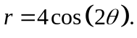
Do not evaluate.

Homework: Worksheet and AP Review 7-9

Notes on Polar, Day 3
Ex. Sketch, and set up an integral expression to find the area inside the graph of 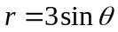 and
outside the graph of 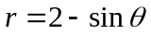. Do not evaluate.

_________________________________________________________________________________________
Ex. Sketch, and set up an integral expression to find the area of the common interior of
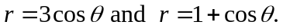

Homework: Worksheet and AP Review 10-11

More on Polar Graphs
Use your graphing calculator on the following example.
Ex. A curve is drawn in the xy-plane and is described by the equation in polar coordinates
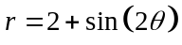 for 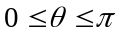, where r is measured in meters and is measured in radians.
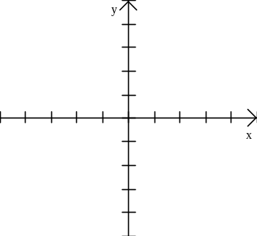
(a) Sketch the graph of the curve.
Note: On your TI-89, is the green diamond function of the
carat key.

(b) Find the area bounded by the curve and the x-axis.

(c) Find the angle that corresponds to the point on the curve with x-coordinate 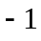.

In function mode, let 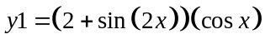
and 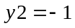 and find the intersection
or on the home screen of your TI89: solve
(d) Find the value of 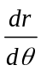 at the instant that 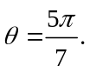 What does your answer tell you about r?
What does it tell you about the curve?

(e) A particle is traveling along the polar curve given by so that its position at time t
is 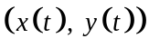 and such that 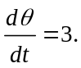 Find the value of 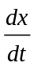 at the instant that 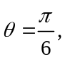and interpret
the meaning of your answer in the context of the problem.

Homework: Worksheet and AP Review 12-13

